**Azure AD App Registration Guide for AD Authentication & Authorization**

**Use Case: Business Users + Service Principals (OAuth2: Authorization Code + Client Credentials Flow)**

This guide walks through setting up Azure AD app registrations to support:

* **Authorization Code Flow** for human users (frontend → backend)

**Use case**: Human users accessing a backend API via a frontend app (like React SPA).

* **Client Credentials Flow** for service/service users (backend → backend)
* Centralized **roles/scopes/groups-based access control**

**Part 1: App Registration for Users Authorization Code Flow (Frontend → Backend)**

**React → MSAL → Azure AD → Token → Backend with Authorization: Bearer**

**🔷 Step 1: Register the Backend API**

1. Go to **Azure Portal** → **Azure Active Directory** → **App registrations** → **New registration**
2. Name: Backend API App
3. Supported account types:  
   Accounts in this organizational directory only
4. Redirect URI:  
   *(Leave blank — backend doesn’t require redirect)*
5. Click **Register**

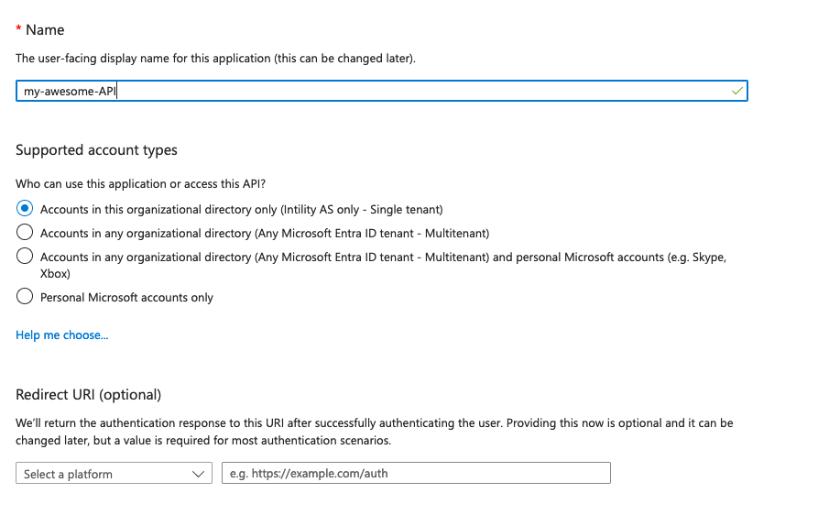

**✅ Save:**

* Application (client) ID
* Directory (tenant) ID

**🔷 Step 2: Define App Roles (RBAC)**

1. Go to the **"App roles"** section of the registered app
2. Click **+ Create app role**
3. Add roles like:

1. Repeat for Manager, User, etc.
2. Click **Save and expose roles**

**🔷 Step 3: Expose API Scopes**

1. Go to **Expose an API**
2. Click **Set** for Application ID URI → api://<client-id>
3. Add a scope:
   * Scope name: access_as_user
   * Admin consent display name: Access API as user
   * Who can consent: Admins only
   * Assign required roles (optional)

**Frontend App Registration**

**🔷 Step 1: Register Frontend App (React / SPA)**

1. Go to **App registrations** → **New registration**
2. Name: Frontend React App
3. Supported account types:  
   Accounts in this organizational directory only
4. Redirect URI: http://localhost:3000 (or your deployed URL)
5. Click **Register**

**🔷 Step 2: Grant API Permissions**

1. Go to **Frontend App** → **API permissions**
2. Click **Add a permission** → **My APIs**
3. Select the Backend API App
4. Choose scope: access_as_user
5. Click **Grant admin consent**

**🔷 Step 3 Optional — Assign Roles to Users or Groups**

* Go to **Enterprise Applications** → Find your backend app
* Open **Users and Groups**
* Assign Azure AD users or groups to the roles created earlier

**✅ Flow Summary (Authorization Code Flow)**

| **Actor** | **Action** |
| --- | --- |
| Human User | Logs in through React SPA using MSAL |
| React App | Requests token from Azure AD with access_as_user scope |
| Azure AD | Returns access token to frontend |
| React App | Sends token to FastAPI via Authorization: Bearer |
| FastAPI | Validates token, checks roles, serves API |

**Backend → Backend / Service-to-Service API - App Registration - Client Credentials Flow**

**service fastapi-aad1 api calls to** **zfast_api_app api**

**Part 2: App Registration for Service Principals (Client Credentials Flow)**

**🔶 Step 1: Register a Service Client App**

1. Go to **App registrations** → **New registration**
2. Name: Backend Service Client
3. Supported account types:  
   Accounts in this organizational directory only
4. Redirect URI: *(leave blank)*
5. Register the app

**🔶 Step 2: Create Client Secret**

1. In the new app, go to **Certificates & Secrets**
2. Click **+ New client secret**
3. Set expiration (e.g., 6 months, 12 months)
4. Save the **value** immediately (you won't see it again)

**🔶 Step 3: Grant API Access to Backend API (fastapi-aad1 api calls to** **zfast_api_app api)**

1. Go to **API Permissions** → **Add a permission**
2. Select **My APIs**
3. Choose Backend API App
4. Select scope: access_as_user OR add a custom **Application-only** scope (optional)
5. Click **Grant admin consent**

**🔶 Step 4: (Optional) Expose Application-only Scopes**

In **Backend API App** → Expose an API:

* Define new scope:
  + Name: access_as_app
  + Who can consent: Admins only
  + Assign to **Application** only (vs. User)

**🔶 Step 5: Use service principle client and secret to generate token**

**✅ Flow Summary (Client Credentials Flow)**

| **Actor** | **Action** |
| --- | --- |
| Service A | Calls Azure AD for token using secret |
| Azure AD | Returns access token with access_as_user or .default scope |
| Service A | Sends token to Backend API in Authorization header |
| Backend API | Validates token, authorizes request |

**🔐 Security Best Practices**

* Rotate client secrets frequently
* Use **Key Vault** for secret storage
* Enforce **least privilege** via scopes & roles
* Use **RBAC** to restrict endpoint access
* Validate:
  + aud (audience matches backend)
  + iss (token issued by Azure)
  + exp (not expired)
  + roles (if applicable)

**✅ 1. Authorization Code Flow (Frontend → Backend)**

**Use case**: Human users accessing a backend API via a frontend app (like React SPA).

* **Backend API app registration**
  + Registers a resource (API) in Azure AD
  + Defines **roles (RBAC)** and **API scopes** (access_as_user)
  + Uses api://<client-id> format for Application ID URI
* **Frontend app registration**
  + Uses MSAL to request tokens
  + Adds API permissions to call the backend
  + Handles **admin consent** properly
* **Flow summary is accurate**:
  + React → MSAL → Azure AD → Token → Backend with Authorization: Bearer
  + Backend validates token and applies role checks

**✅ 2. Client Credentials Flow (Backend → Backend / Service-to-Service)**

**Use case**: Machine-to-machine communication between services (e.g., microservices or backend jobs).

* **Service client app registration**
  + No redirect URI needed
  + Uses client secret
* **Backend API app registration**
  + Exposes API scopes (e.g., access_as_service)
  + Permissions granted via API permissions
* client authenticating using **client ID + secret** to get a token and call another API